**Assingment – 3**

* **Use ps to search for the “systemd” process by name.**



* **Find out your terminal name.Using your terminal name, use ps to find all processes associated With your terminal.**

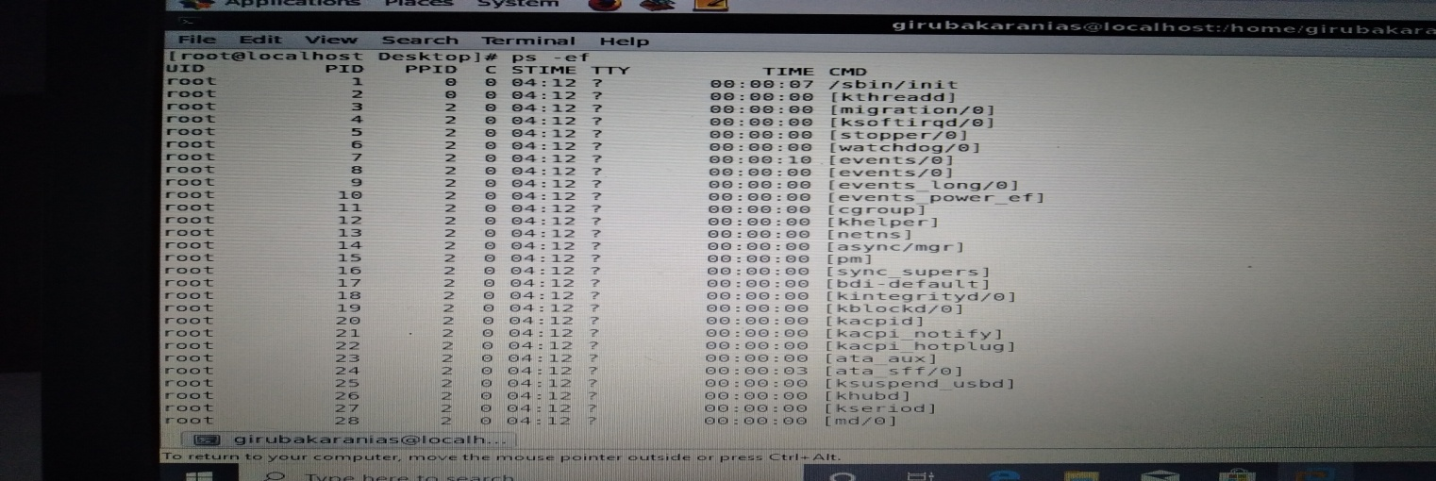

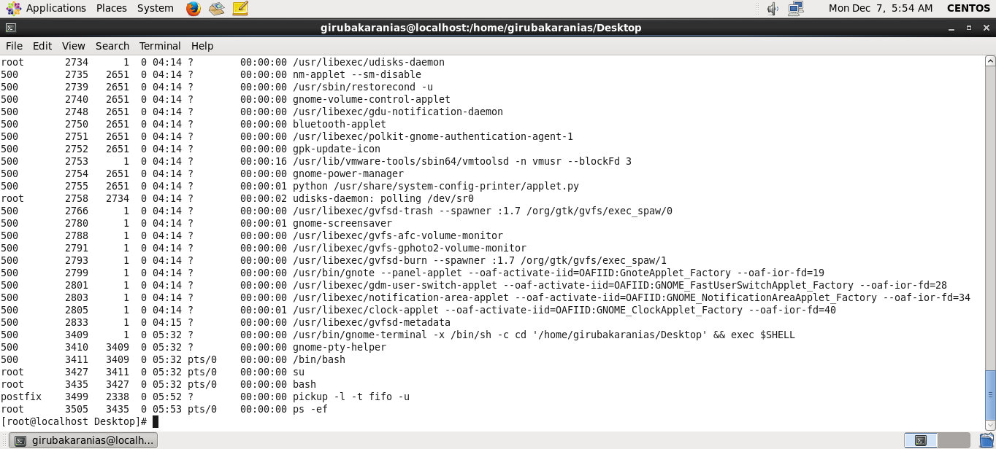

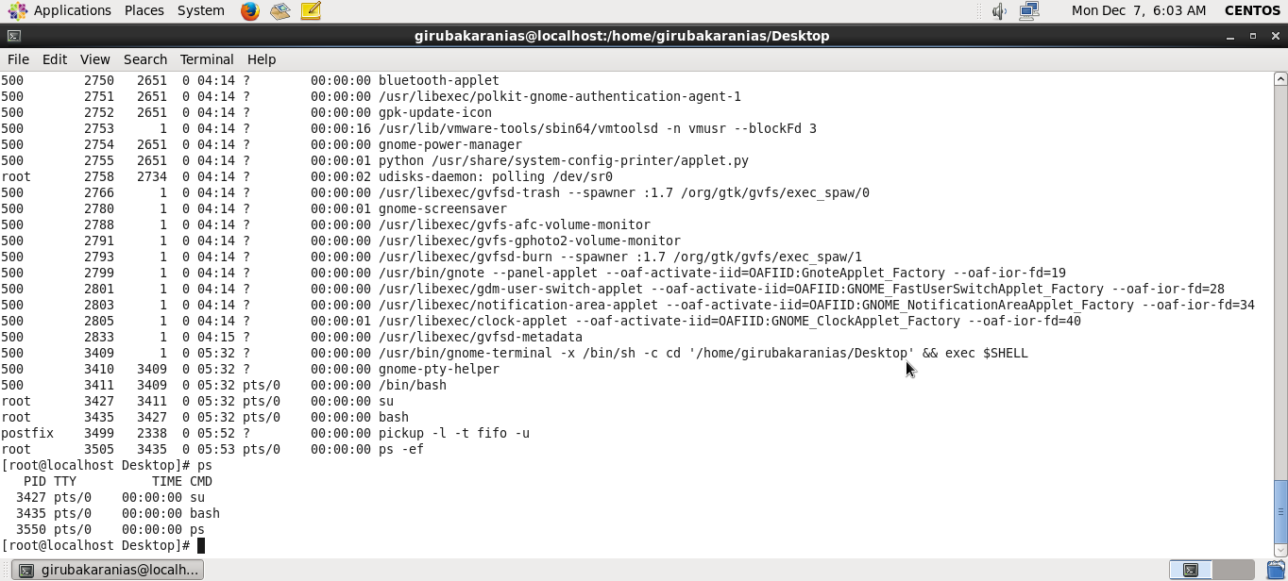

* **Check and note the process id of your shell(from the output of the above command). Also, note the parent process id of your shell.**

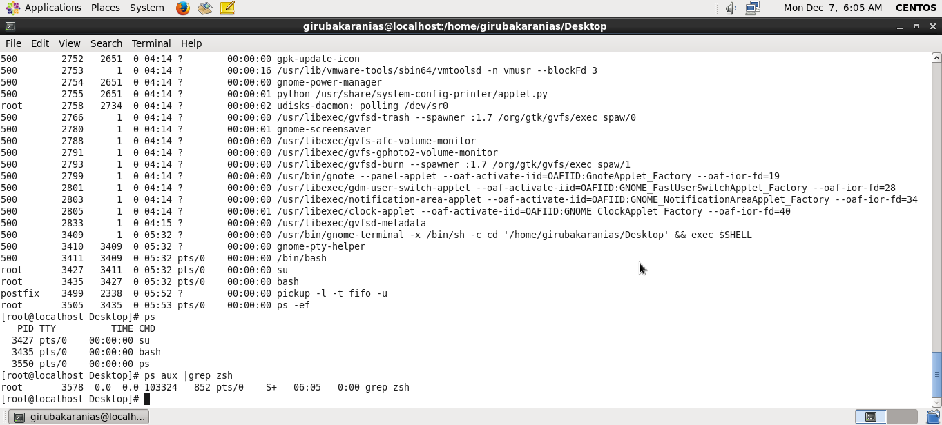

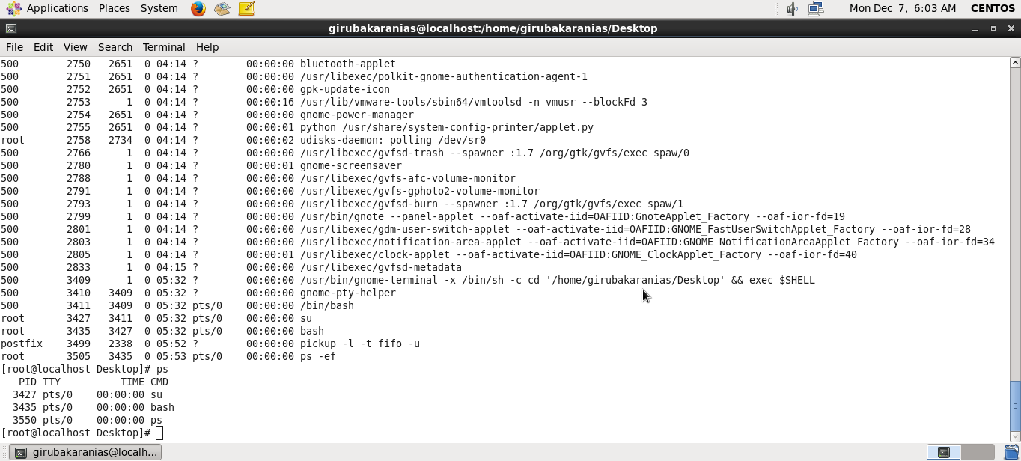

* **Start 3 instances of “sleep 123” as background processes.**

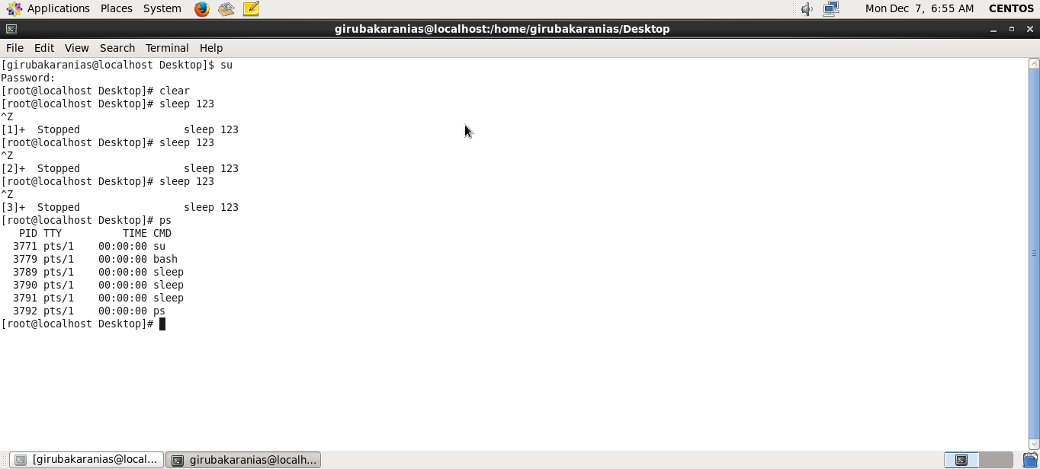

* **Check and note the process id’s of all sleep processes.**

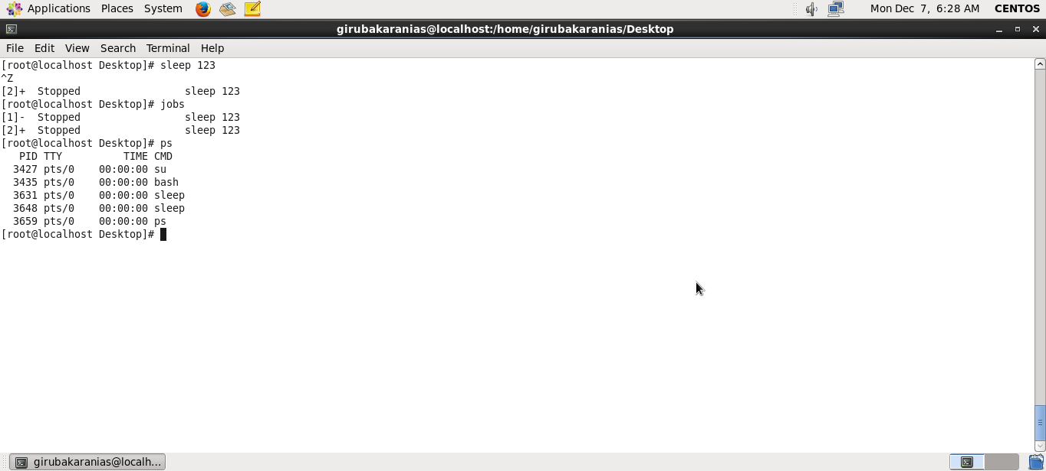

* **Display only those three sleep processes in top. Then quit top.**

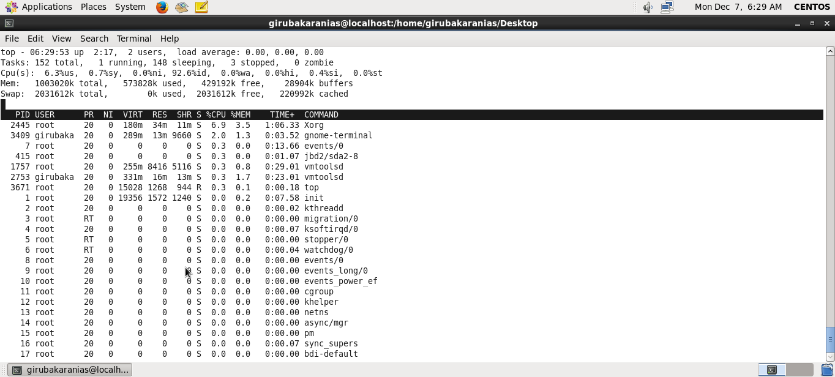

**Thanking You!**

**Shubham Prakash**